JOB DESCRIPTION

JOB DETAILS
Post title: | Area Revenues Officer (Benefits)
Post grade: | E
Directorate: | Corporate Services
Section: | Revenues and Benefits
Reporting to: | Benefits Manager
Line manager: | No
Date updated: | March 2024
MAIN PURPOSE OF JOB
Under the general supervision of the Benefits Team Leader responsible for the administration of Housing Benefit and Council Tax Reduction claims.
To manage all avenues of customer contact in line with council standards
To ensure we maximise income for residents, through guidance and signposting to relevant support.
Ensure accuracy and compliance in the administration of benefit and council tax reduction, protect the authority subsidy.
SPECIFIC DUTIES
To check and verify information received in support of applications for Council Tax Reduction and Housing Benefit using all available information sources.

Assess and review entitlement to Council Tax Reduction and Housing Benefit in line with relevant legislation and Council policies and procedures from a variety of claimant groups.

To be aware of the subsidy implications when processing claims and where possible take action to prevent any penalties to the Council. To be aware of any possible fraudulent claims and refer these to the Counter Fraud and Enforcement Unit.

To provide up to date and quality advice to customers on Benefits matters and understand and be able to advise customers about other welfare benefits.

Respond to enquiries from customers regarding any matters relating to Council Tax Reduction and Housing Benefit in person, by telephone, email and in writing.

Communicate effectively with other teams in the Council and external agencies such as CAB, housing associations and landlords.

Provide ad hoc support to the Revenues team as and when required including processing less complex enquiries and dealing with telephone calls and emails from council tax and business rates payers.

To prioritise workload to achieve service targets and ensure that a proactive approach is always used where there is a need to contact customers for further information or evidence in support of their application

To adhere to all Council Policy, in particular Equal Opportunities.

To undertake any other duties properly assigned from time to time by the Revenues and Benefits Manager which are appropriate to the grade and character of the post.

Ensure that services are delivered in compliance with existing and new Health and Safety legislation and the Council’s Health and Safety Policy and ensuring that duties are pursued in a safe manner with due regard to the health and safety of yourself and others.

ORGANISATIONAL CHART
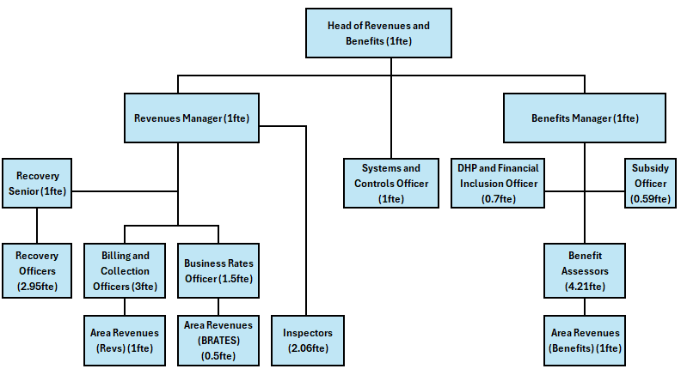
KEY WORKING RELATIONSHIPS
Internal – Head of Service, Team Leaders, Revenues department, Customer Service, Finance, Housing, Electoral Services
External – Claimants, Councillor’s, Jobcentre plus, Department for Works and Pensions, Housing Associations, Landlords, Counter Fraud and Enforcement Unit (CFEU), food bank, other support charities/networks
RESOURCES
Access to confidential or sensitive data required to determine eligibility to Housing Benefit, Council Tax Reduction must be treated securely and in line with GDPR and Department for Works and Pensions Memorandum of Understanding.
The post holder will have a responsibility to determine the correct level of Housing Benefit and assist with protecting the Local Authorities yearly subsidy claim by ensuring fraud and error is avoided.
The Welfare Officer will be responsible for signposting claimants for other assistance to help with their current circumstances, ensuring residents receive the maximum benefit they are entitled too.
PHYSICAL DEMANDS
Ability to manage an elevated level of customer contact, always remaining professional and courteous.
Requirement to sit at a desk in front of a computer for extended periods for most of the week.
The role involves making sure our residents and housing associations/landlord are aware of the application process – this will involve attending various community groups, housing associates to provide clear instructions on the application process and guidance.
The emotional demand involved with assisting our most vulnerable residents, including those residents on very low incomes, facing homelessness or suffering from domestic violence, may affect physical health and the post holder will need to have the ability to identify and raise any concerns they have around stress and effect on mental health, so that support can be provided to assist the post holder.
MENTAL DEMANDS
The role requires the post holder to assist some of our more vulnerable residents within the Borough, this can regularly involve upsetting conversations, which may result in challenging customer situations.
The post holder will need to understand and process constantly changing complex legislation and be able to explain the information in an understandable manner.
The role involves working to tight deadlines and is often stressful due to the nature of the post, the post holder will need to be able to prioritise workload and identify critical situations to ensure Housing Benefit and Council Tax Reduction is awarded without delay.
The post holder will be required to remain calm and empathetic to customers’ requirements and can manage telephone calls and respond to emails/written correspondence in a compassionate manner.
The post holder will be required to discuss options for customers facing financial difficulty and this will/can lead to conflict and confrontation on a regular basis. The post holder will be required to remain calm and clear when resolving enquiries.
The position will be supported by the Revenues Manager and Head of Service; however, the post holder will be required to extensively use their initiative and must possess good decision-making skills to resolve situations independently.
Due to the nature of the post, the post holder may be made aware of safeguarding situations, and they will need to understand the process of reporting these in a confidential and sensitive way and signpost/guide staff as and when required..
WORKING ENVIRONMENT
The post is hybrid and will involve working 60% of the time in the office and 40% home working.
The role involves occasions when the behaviour of others may be challenging, and the post holder will be provided with support to help manage these situations.
The post holder may on occasions be required to attend visits within the Tewkesbury Borough area to verify entitlement to benefit or reductions.
Occasional duty cover will be required involving face to face visits from our residents to the office.
As part of the role, you will be asked to provide occasional duty cover, which could include face-to-face visits from residents at the office. These visits will involve addressing queries and providing assistance as needed, requiring you to be approachable, clear, and empathetic.
ALL STAFF RESPONSIBILITIES
To adhere to all Council Policies, in particular Equal Opportunities.
To undertake any other duties properly assigned from time to time by your line manager which are appropriate to the grade and character of the post.
To be committed to the principles of equality, diversity, and the ability to treat everyone who you encounter dignity and respect.
Tewkesbury Borough Council is committed to the principles of safeguarding and promoting the welfare of all children, young people, and vulnerable adults; therefore, all employees have a responsibility and duty of care to report safeguarding issues they become aware of or witness.
HEALTH AND SAFETY
Ensuring that services are delivered in compliance with existing and new Health and Safety legislation and the Council’s Health and Safety Policy and ensuring that duties are pursued in a safe manner with due regard to the Health and Safety of yourself and others.

PERSON SPECIFICATION
QUALIFICATIONS |  | ESSENTIAL | DESIRABLE | ASSESSMENT METHOD
A good basic education including English and Math’s |  | ☒ | ☐ | Application form
IRRV Tech |  | ☐ | ☒ | Application form
NVQ or similar qualification in customer services |  | ☐ | ☒ | Application form
EXPERIENCE |  | ESSENTIAL | DESIRABLE | ASSESSMENT METHOD
Proven experience in customer service, administration, finance or welfare support |  | ☒ | ☐ | Application and interview
Proven experience in a customer contact environment |  | ☒ | ☐ | Application and interview
Evidence of decision making and working independently |  | ☒ | ☐ | Application and interview
Experience of working with Microsoft office and various other IT systems. |  | ☒ | ☐ | Application and interview
Previous experience of managing data and an understanding of GDPR |  | ☒ | ☐ | Application and interview
Experience of working in a debt advisory or financial role |  | ☐ | ☒ | Application and interview
SKILLS |  | ESSENTIAL | DESIRABLE | ASSESSMENT METHOD
Excellent communication skills, including the ability to manage customers expectations |  | ☒ | ☐ | Application and interview
Strong attention to detail and confidence handling information |  | ☒ | ☐ | Application and interview
Ability to work to a high degree of accuracy for extended periods of time |  | ☒ | ☐ | Application and interview
Excellent organisational skills, including the ability to prioritise tasks |  | ☒ | ☐ | Application and interview
Ability to work in a demanding environment with pressure to meet deadlines. |  | ☒ | ☐ | Application and interview
Clear communication skills and a calm, empathetic approach |  | ☒ | ☐ | Application and interview
BEHAVIOURS / ATTRIBUTES |  | ESSENTIAL | DESIRABLE | ASSESSMENT METHOD
Builds effective and professional working relationships with staff, customers, internal and external stakeholders |  | ☒ | ☐ | Application and Interview
Willingness to learn complex rules and apply them accurately |  | ☒ | ☐ | Application and Interview
Remains fair and consistent |  | ☒ | ☐ | Application and Interview

