JOB DESCRIPTION

JOB DETAILS
Post title: | Customer Services Advisor
Post grade: | D
Directorate: | Transformation
Section: | Customer, Programmes and Performance
Reporting to: | Customer Services Manager
Line manager: | No
Date updated: | November 2025
MAIN PURPOSE OF JOB
The customer services advisor role provides high quality customer service across the council, focusing on meeting the needs of residents and prioritising customer experience

Responsibilities include being the first point of contact for customer enquiries which are received through a range of communication channels. Cases are logged through the council’s customer relationship management systems and forms.

The role requires collaborative working with services, partners and subcontractors to achieve the best outcomes for customers.

The role must possess excellent communication and IT skills, the ability to adapt to new technologies and a positive, proactive mindset.

SPECIFIC DUTIES
- To be the first point of contact for and respond to telephony, email and live chat enquiries received via the councils multi-channel contact center solution.

- Ensure the smooth running of the Public Service Centres busy front reception desk, greet in-person visitors, triage enquiries and signpost to appropriate council and partner services.

- To use a range of information systems and software platforms to accurately log service requests, record customer feedback and relay enquiries to other council services.

- To ensure efficient logging and allocation of the council’s complaints and Freedom of Information requests.

- To liaise with and build positive working relationships with partners and subcontractors to ensure effective delivery of services and a high standard of customer care.

- To take payments and manage refunds using the council’s approved payment processing software.

- To manage realistic expectations with customers in line with council and service specific policies and procedures.

- To own the customer’s experience with us by monitoring responses, giving timely updates and managing enquiries through to completion, escalating more challenging or complex customer enquiries or interactions to the Customer Services Manager.

- To understand and contribute towards achieving service related performance indicators.

- To embrace our culture of continuous improvement and support the delivery of the council’s emerging digital strategy.

- To support a culture of working together and being a champion for customer service across the organisation.

- To promote self-service options and guide customers through online platforms.

- Maintain up-to-date knowledge of council policies, procedures and service changes.

- Support vulnerable residents with empathy and discretion

ORGANISATIONAL CHART
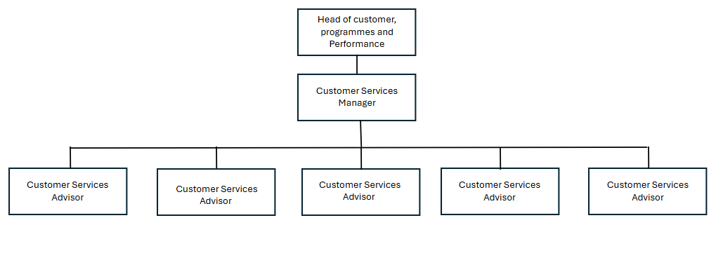
KEY WORKING RELATIONSHIPS
Head of Customer, Programmes and Performance
Customer Services Manager
Customer Services Advisors
Ubico supervisors and operations administrators
Wilmond Waste operations team
Orchard Recycling operations team

RESOURCES
This post-holder has responsibility for the safe management of customer information, including a wide range of data from a variety of sources.

PHYSICAL DEMANDS
None.

MENTAL DEMANDS
The role manages high volumes of customer enquiries with sustained focus, navigating multiple systems, listening actively, and responding accurately in real time. They will interpret issues, apply council procedures, and exercise judgement in prioritising enquiries, resolving matters independently or escalating when necessary. The role requires frequent task-switching under time pressure, handling simultaneous enquiries while updating records and coordinating with other departments. Professionalism, resilience, and adaptability are essential when supporting distressed, angry, or vulnerable customers, ensuring service quality across diverse customer profiles and enquiry channels.

WORKING ENVIRONMENT
The role offers the opportunity for hybrid working subject to the needs of the service. A standard working week may involve one or two days working from home and will include one day working on the reception desk at the council offices.
ALL STAFF RESPONSIBILITIES
To adhere to all Council Policies, in particular Equal Opportunities.

To undertake any other duties properly assigned from time to time by your line manager which are appropriate to the grade and character of the post.

To be committed to the principles of equality, diversity and the ability to treat everyone who you come in contact with dignity and respect.

Tewkesbury Borough Council is committed to the principles of safeguarding and promoting the welfare of all children, young people and vulnerable adults; therefore, all employees have a responsibility and duty of care to report safeguarding issues they become aware of or witness.

HEALTH AND SAFETY
Ensuring that services are delivered in compliance with existing and new Health and Safety legislation and the Council’s Health and Safety Policy and ensuring that duties are pursued in a safe manner with due regard to the Health and Safety of yourself and others.

PERSON SPECIFICATION
QUALIFICATIONS |  | ESSENTIAL | DESIRABLE | ASSESSMENT METHOD
General education to GCSE standard or equivalent. |  | ☒ | ☐ | Application
NVQ level 2 Customer Service or equivalent. |  | ☐ | ☒ | Application
EXPERIENCE |  | ESSENTIAL | DESIRABLE | ASSESSMENT METHOD
Experience working in a customer service environment. |  | ☒ | ☐ | Application & interview
Experience of working in local government |  | ☐ | ☒ | Application & interview
Experience working in a call handling or contact center environment. |  | ☐ | ☒ | Application & interview
Experience working in a front facing reception based environment. |  | ☐ | ☒ | Application & interview
Experience in using digital platforms, Customer Relationship Management systems and electronic forms. |  | ☒ | ☐ | Application & interview
Experience using Microsoft Office, including Teams. |  | ☒ | ☐ | Application & interview
Team working |  | ☒ | ☐ | Application & interview
Experience of handling complaints and resolving queries efficiently and empathetically |  | ☒ | ☐ | Application & interview
SKILLS |  | ESSENTIAL | DESIRABLE | ASSESSMENT METHOD
Excellent verbal and written communication skills. |  | ☒ | ☐ | Application & interview
Strong interpersonal skills |  | ☒ | ☐ | Application & interview
Strong IT skills with the ability to adapt to new technologies. |  | ☒ | ☐ | Application & interview
Ability to work with accuracy and attention to detail. |  | ☒ | ☐ | Application & interview
Excellent organisational skills and the ability to prioritise tasks. |  | ☒ | ☐ | Application & interview
Ability to work collaboratively and build positive working relationships. |  | ☒ | ☐ | Application & interview
Ability to remain calm and work effectively under pressure. |  | ☒ | ☐ | Application & interview
Ability to work independently and as part of a team. |  | ☒ | ☐ | Application & interview
BEHAVIOURS / ATTRIBUTES |  | ESSENTIAL | DESIRABLE | ASSESSMENT METHOD
Positive attitude to work with a commitment to delivering excellent customer service. |  | ☒ | ☐ | Application & interview
Open to change and embraces our culture of continuous improvement.. |  | ☒ | ☐ | Application & interview
Flexible and adaptable to changing demands and technology |  | ☒ | ☐ | Application & interview
Professional, courteous and resilient in all interactions |  | ☒ | ☐ | Application & interview
Friendly and approachable. |  | ☒ | ☐ | Application & interview
Empathy, patience and a genuine desire to help others |  | ☒ | ☐ | Application & interview
Commitment to equality, diversity and inclusion in service delivery |  | ☒ | ☐ | Application & interview

