JOB DESCRIPTION

JOB DETAILS
Post title: | Business Rates Officer
Post grade: | E
Directorate: | Corporate Services
Section: | Revenues and Benefits
Reporting to: | Revenues Manager
Line manager: | No
Date updated: | March 2024
MAIN PURPOSE OF JOB
To be an officer in the Revenues Team with specific responsibility for maintaining and safeguarding the Council’s Business Rates base through establishing liability and dealing with collection and enforcement.
To provide in-depth advice and information about Business Rates to customers.
To also be responsible for the accurate maintenance of the Valuation List.
SPECIFIC DUTIES
To correctly bill, apply appropriate reliefs and exemptions and promptly collect individual Business Rates accounts. Where necessary arrange appropriate enforcement action including referral to enforcement agents

Liaise with the Valuation Office Agency regarding amendments to the Rating List and ensure that all schedules and transitional relief certificates are actioned promptly, so the Council’s rateable value is accurate and income from Business Rates is fully realised.

To assist in all stages of the billing and recovery process including establishing liability and dealing with customer enquiries which arise by telephone, email or letter providing an excellent, polite and courteous public service at all times.

To ensure all amendments to the Valuation List are actioned promptly so the Council’s income from Council Tax is accurate and fully realised.

To assess applications for rate relief in accordance with the Local Government Finance Act 1988 and Council policy guidelines and procedures

Ensure that any suspicions of irregular or fraudulent claims or accounts are referred
to the Counter Fraud Unit. To also take all positive steps to maximise the rateable value for the authority and income from government grants

To possess sufficient technical knowledge of Business Rates to be able to deal accurately and authoratively with customers and their representatives such as surveyors and other agents.

To increase the rateable value in the Borough through the coordination and monitoring of all information sources within the Council (particularly Planning) and the practical application of this information to fully realise income from Business Rates. To include being the Business Rates representative in the Growth Hub.

To prioritise workload to achieve service targets and maximise collection ensuring that a proactive approach is always used where there is a need to contact
customers for further information or evidence in support of their account or debt.

To provide support as and when required for the billing, collection and enforcement of Council Tax.

To adhere to all Council Policy, in particular Equal Opportunities.

To undertake any other duties properly assigned from time to time by the Revenues and Benefits Manager which are appropriate to the grade and character of the post.

Ensure that services are delivered in compliance with existing and new Health and Safety legislation and the Council’s Health and Safety Policy and ensuring that duties are pursued in a safe manner with due regard to the health and safety of yourself and others.

ORGANISATIONAL CHART
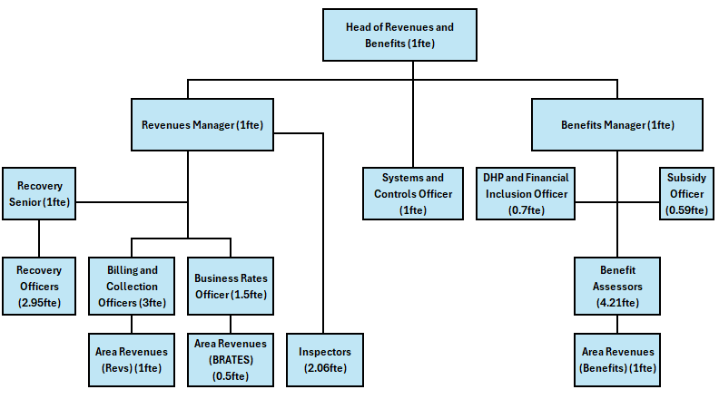
KEY WORKING RELATIONSHIPS
Internal – Head of Service, Managers, Revenues department, Customer Service, Finance, Planning, Electoral Services
External – Valuation Office Agency, HMRC, Ratepayers, Business Representatives, MP’s, Landlords, Counter Fraud and Enforcement Unit (CFEU), other support networks
RESOURCES
Access to confidential or sensitive data required to determine eligibility to Business Rates discounts, reliefs and exemptions must be treated securely and in line with GDPR.
The post holder will have a responsibility to determine the correct liability for all business rated property within the Borough and ensure fraud and rate avoidance is treated within current regulations.
The Business Rates Officer will be responsible for signposting Businesses to other avenues of assistance to help with their current circumstances, ensuring businesses receive any discounts/reliefs or exemptions they may be entitled too.
PHYSICAL DEMANDS
The role will involve a significant amount of desk-based work, where you may be required to sit for extended periods.
During this time, you will perform telephone and reception duties, interacting with clients, answering queries, and providing assistance.
The role demands attention to detail and the ability to manage calls efficiently while maintaining a professional and approachable demeanor.
A key part of the role will be conducting regular site visits and inspections to verify the accuracy of data. These visits will involve meeting with local businesses, reviewing properties, and gathering information to ensure compliance and accuracy in our records.
The post requires a keen eye for detail, the ability to work independently, and the flexibility to move between office-based tasks and visits.
MENTAL DEMANDS
To assist ratepayers within the Borough by providing efficient, empathetic, and effective Business Rates services, including billing, collection, and recovery actions in accordance with the Local Government Finance Act 1988 and the Council's policies and procedures.
The role requires managing complex and sometimes challenging customer situations, including negotiating payment arrangements and addressing difficult conversations, often involving vulnerable or financially struggling businesses.
The postholder will be responsible for assessing and managing Business Rates liabilities, exemptions, and reliefs, ensuring compliance with legislation and Council policy, and working to tight deadlines.
The role requires a high level of interpersonal skill to manage customer expectations and provide clear, concise explanations of complex and frequently changing legislation, ensuring that information is communicated effectively to residents, business owners, representatives, and landlords
A key aspect of the role involves negotiating payment arrangements, balancing the debtor's circumstances with the Council's need to collect outstanding income, and escalating cases when necessary for further recovery action.
The postholder will also need to remain calm and compassionate in high-pressure situations, often dealing with conflict and confrontation, while maintaining a professional and confidential approach.
The role demands a high level of initiative, decision-making skills, and the ability to prioritise workload to meet strict deadlines.
The postholder will also need to identify and handle safeguarding concerns, reporting such issues in a sensitive and confidential manner as required.
The role is supported by the Revenues Manager and Head of Service but requires significant independence and good judgment to resolve cases and maintain efficient service delivery.
The postholder will ensure the timely billing and collection of Business Rates, while providing crucial support to businesses and residents, particularly those facing financial hardship.
WORKING ENVIRONMENT
This hybrid role offers a balanced work arrangement, with 60% of your time spent in the office and 40% working remotely, giving you the flexibility to manage your workload effectively while maintaining strong team collaboration.
The post will be part of a close-knit team that values collaboration, open communication, and mutual support. Regular in-office days will give you the opportunity to engage directly with colleagues, share insights, and contribute to team success.
The postholder will have the opportunity to make regular visits to businesses within the area to discuss liabilities, ratable values, and outstanding enquiries.
This is a client-facing role that requires effective communication skills and the ability to remain calm and confident when discussing complex matters. The goal will be to foster constructive conversations and resolve any concerns effectively.
As part of the role, you will be asked to provide occasional duty cover, which could include face-to-face visits from residents at the office. These visits will involve addressing queries and providing assistance as needed, requiring you to be approachable, clear, and empathetic.
ALL STAFF RESPONSIBILITIES
To adhere to all Council Policies, in particular Equal Opportunities.
To undertake any other duties properly assigned from time to time by your line manager which are appropriate to the grade and character of the post.
To be committed to the principles of equality, diversity, and the ability to treat everyone who you encounter dignity and respect.
Tewkesbury Borough Council is committed to the principles of safeguarding and promoting the welfare of all children, young people, and vulnerable adults; therefore, all employees have a responsibility and duty of care to report safeguarding issues they become aware of or witness.
HEALTH AND SAFETY
Ensuring that services are delivered in compliance with existing and new Health and Safety legislation and the Council’s Health and Safety Policy and ensuring that duties are pursued in a safe manner with due regard to the Health and Safety of yourself and others.

PERSON SPECIFICATION
QUALIFICATIONS |  | ESSENTIAL | DESIRABLE | ASSESSMENT METHOD
A good basic education including English and Math’s |  | ☒ | ☐ | Application form
IRRV Tech |  | ☐ | ☒ | Application form
NVQ or similar qualification in customer services |  | ☐ | ☒ | Application form
EXPERIENCE |  | ESSENTIAL | DESIRABLE | ASSESSMENT METHOD
Proven experience working in a similar role where decisions are bound by regulations/law |  | ☒ | ☐ | Application and interview
Proven experience in a customer contact environment with a focus on high-volume interactions. |  | ☒ | ☐ | Application and interview
Evidence of decision making and working independently in a similar role |  | ☒ | ☐ | Application and interview
Experience of working within a Revenues and Benefit, financial environment, or other government department |  | ☒ | ☐ | Application and interview
Previous experience of managing sensitive data and a good understanding of GDPR |  | ☒ | ☐ | Application and interview
Experience of working in a debt advisory or financial role |  | ☐ | ☒ | Application and interview
SKILLS |  | ESSENTIAL | DESIRABLE | ASSESSMENT METHOD
Excellent communication skills, including the ability to manage customers understanding of complex legislation |  | ☒ | ☐ | Application and interview
Ability to communicate complex legislation clearly in writing/email |  | ☒ | ☐ | Application and interview
Ability to work to a high degree of accuracy |  | ☒ | ☐ | Application and interview
Excellent organisational skills, including the ability to prioritise tasks |  | ☒ | ☐ | Application and interview
Ability to work in a demanding environment with pressure to meet deadlines. |  | ☒ | ☐ | Application and interview
Strong analytical and critical thinking skills with the ability to identify issues and implement appropriate solutions. |  | ☒ | ☐ | Application and interview
BEHAVIOURS / ATTRIBUTES |  | ESSENTIAL | DESIRABLE | ASSESSMENT METHOD
Builds effective and professional working relationships with staff, customers, internal and external stakeholders |  | ☒ | ☐ | Application and Interview
Embraces and helps to support others through periods of change |  | ☒ | ☐ | Application and Interview
Remains fair and consistent |  | ☒ | ☐ | Application and Interview

